Machine Learning Project – Report 1

Exploratory Data Analysis and Feature Engineering

Team: Nithin K , Romeal N , Sied
Project: #mar26_bds_int_co2
Date: 26.04.2026

Introduction to the Project

This project focuses on analyzing and predicting CO2 emissions from vehicles registered in Europe, using the 2024 dataset from the European Environment Agency (EEA). Transportation is a major contributor to greenhouse gas emissions, and predictive modeling can help stakeholders take proactive decisions.

Context

Business Context
Identifying high-emission vehicles supports regulatory compliance and pollution prevention in transportation, a key CO2 source, aiding manufacturers and policymakers in France and EU markets. This prediction model supports :
- France's climate policy and Paris Agreement commitments
- Consumer decision-making for eco-friendly vehicle choices
- Automotive manufacturers in designing lower-emission vehicles
- Regulatory authorities in emission standard enforcement
Predictive modeling enables proactive intervention before new high-emission vehicle models enter the market.

Technical Context
The analysis employs data cleaning, feature engineering, and EDA with pandas, seaborn, and matplotlib on a large dataset (~10M rows), preparing for ML models like regression on WLTP CO2 emissions. The project employs classical machine learning with interpretable features rather than deep learning. The approach combines:

- Exploratory data analysis for pattern discovery
- Feature engineering based on automotive engineering principles
- Classical ML models (Regression,Ridge,ElasticNet,Random Forest, XGBoost, etc.)
- Transparent predictions suitable for regulatory contexts

Economic Context
Feature-based ML approaches are economically advantageous:
- lower computational cost
- reduced hardware requirements
- faster training and inference
- Cost-effective scalability for annual vehicle databases

This makes the solution accessible to government agencies, manufacturers, and environmental organizations with limited budgets.

Scientific Context

- The project follows established automotive engineering and environmental science principles.
- Physics-based understanding (mass, engine displacement, fuel type affecting emissions)
- Regulatory frameworks (Euro emission standards)
- Data-driven discovery of correlations between vehicle characteristics and CO₂

Objectives

Main Objectives
The main objectives are:
- building a robust and reproducible preprocessing and feature extraction pipeline
- exploring ,analyzing and visualizing vehicle emission patterns
- Identifying relevant technical features for CO₂ prediction
- preparing the data for classical machine learning models

Team Expertise
Team members have varying levels of expertise in:
- Python and data science
- Automotive domain knowledge
- machine learning and statistical analysis
- data analysis and visualization
This diversity enabled a distributed development of filtering, feature engineering, and analysis components.

Business Expert Interaction
No direct business experts (automotive or government bodies) were consulted. Feature and model choices are based on:
- ADEME technical documentation
- Euro emission standard specifications
- Automotive engineering literature

Research Questions and Hypotheses
Based on project requirements and limited domain knowledge in emissions & emission controls , the exploration phase of this project is guided by the following research questions:

- RQ1: Do hybrid vehicles exhibit significantly lower CO₂ emissions compared to conventional fuel types when controlling for mass?
- RQ2: Is there a linear or non-linear relationship between vehicle mass and emissions?
- RQ3: Does fuel type influence emissions? If Yes, by how much ?
- RQ4: Are certain vehicle segments associated with higher emissions independent of mass?
The corresponding hypotheses are:
- H1: Hybrid technology reduces emissions by 20-30% compared to non-hybrid equivalents
- H2: CO₂ emissions increase exponentially with vehicle mass beyond (1.7ton)
- H3: High -speed transmissions show optimal efficiency
- H4: Luxury and SUV segments exhibit 25-40% higher emissions than economy segments.
These research questions provide a structured framework for the exploratory data analysis and motivate subsequent feature selection and modeling strategies.

Understanding and Manipulation of Data

Framework

Dataset Description

The 2024 French vehicle registration database from EEA contains:
- CO₂ emissions (g/km)
- Fuel consumption
- Car make , type , fuel, ..etc
- Vehicle characteristics (brand, model, engine, mass, transmission, body type)

Data Ownership
Publicly available via data.gouv.fr under Open License. Used strictly for research and educational purposes.

Source: https://www.eea.europa.eu/en/datahub/datahubitem-view/fa8b1229-3db6-495d-b18e-9c9b3267c02b

Dataset Volume
After preprocessing and feature extraction, the final dataset contains:
- approximately 10779681 samples with 40 column features[~3.2GB]

Relevance of the Data

Target Variable
Primary target: CO₂ emissions (g/km):
- Continuous numerical variable
- Range: 50-400 g/km (ICE) [probable relevant range], 0 g/km (EVs)
- Bimodal , Right-skewed distribution , with 2 major peaks

Relevant Features
Features can be mainly grouped into 3 broad sections:
- Vehicle engineering specs [ m(kg) ,ec(cm3),ep(KW),Ft,Fm,W(mm)…….etc]
- Emissions + Regulatory targets [ Ewltp(g/km),Enedc(g/km),Ernedc,Fuel Consumption,Electtic range(km) ]
- Temporal + policy related [ year, date of registration, country..]
Features for the analysis have been classified as Numerical , Categorical , Target feature in the following report discussions.

Data Limitations
- High cardinality categorical features
- Missing values in multiple columns
- Potential leakage via fuel consumption
- Presence of Large number of Outliers

Pre-processing and Feature Engineering

Data pre-processing : Cleaning & Filtering
- Removed duplicates and irrelevant columns (ID, VFN, etc.)
- Control and correct the datatypes + detect outliers
- Handled missing values using group-wise imputation
- Created “vehicle_type” feature (EV, ICE, Hybrid)
- Extracted temporal features (Month, Day)
- Cleaned Euro emission standards (ech_clean)

Feature Extraction
Explainable features were extracted, including:
- Cyclical encoding for time features
- Group-based imputation for engine and power values

Feature Segregation
Due to heterogeneous features , all the extracted , selected features were grouped as below:
- Numerical ( broad classification from the dataset )
- Categorical ( broad classification from the dataset )
- High Cardinal ( prep for Target Encoding )
- Low Cardinal ( for OneHot Encoding )
- For encoding : ( Month & Day : for Cyclic encoding )

Dimensionality Reduction
Most of features were cleaned , during the early EDA steps and some strong inter-feature correlations for ex., 2 mass based features [ m (kg) , Mt ] were treated after Pearson correlation matrix plot , which is described in the following sections. Main goal of the dimension reduction is to:
- reduce redundancy
- mitigate multicollinearity
- improve model stability

Visualizations and Statistical Insights
Exploratory visualizations were used to analyze both the distribution of individual features, as well as the relationships between explanatory variables and their association with the target variable.

Target Distribution :
Target distribution (EV vs ICE): Shows a bimodal distribution with 2 critical peaks
- Peak 1 (0 g/km) : ~1.56M EVs with zero emissions
- Peak 2 (120-140 g/km) : ~2.2M typical ICE Dominance & from other fuel types
- Right tail : (200-500 g/km) : tells about the high performance , SUVs,or older vehicles with high emissions

The plot in the Figure 1: Target distribution below reveals a clear existence of minimum 2 set of data in one large emission dataset. Since the 1st peak at 0 g/km suggest the presence of EV, since EV has no engine, no fuel intake , hence no or zero emission. From a machine learning perspective, this group of EV has to be taken care during feature identification and grouping of the same for analysis. Therefore, it must be considered during model training and evaluation, particularly when selecting appropriate metrics and modeling strategies.
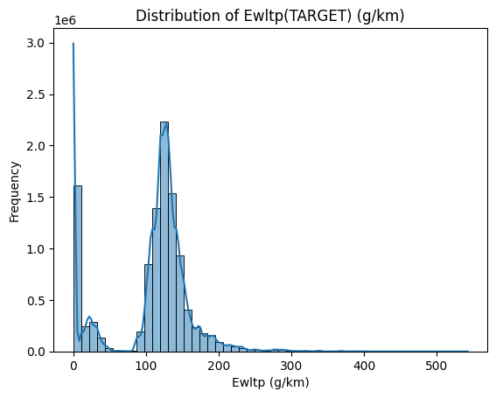

Figure 1: Target distribution .

Correlation Heatmap (Numerical feature only) Vs the target
Boxplots and violin plots were created for selected relevant features, including:

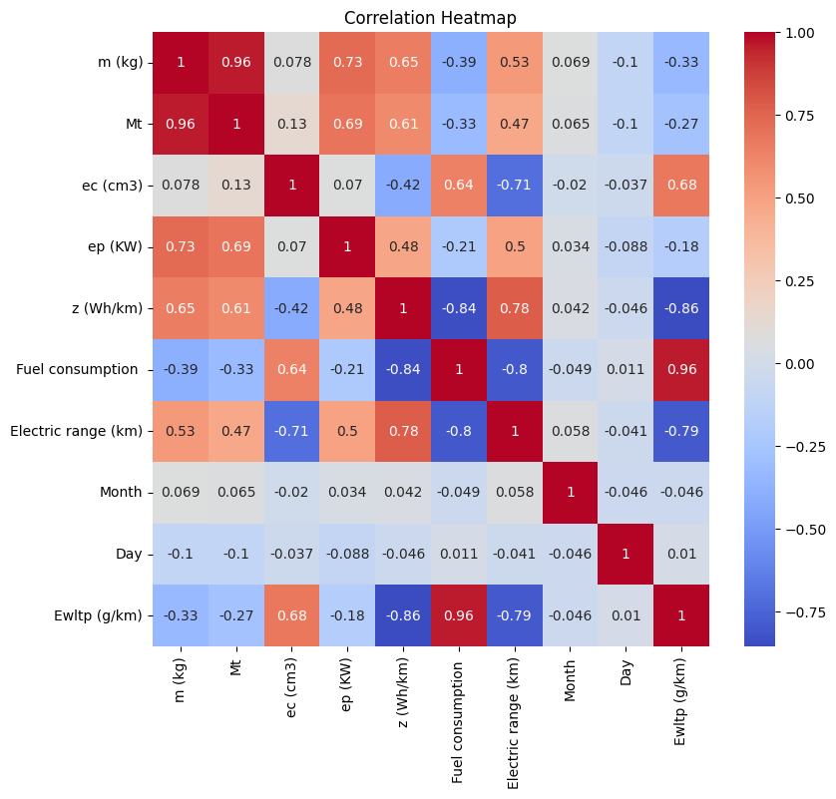
Figure 2: Heatmap of Numerical features Vs Target

Observations:

- Fuel consumption +0.96, Very good /perfect corr — more fuel = more CO2. Risk of data leakage.
- z (Wh/km)-0.86, Strong negative — EVs consume electricity, emit 0 CO2 [***strong negative correlation***]
- Electric range (km)-0.79, Longer EV range → lower emissions ( can be EV or hybrid ) [***strong negative correlation***]
- ec (cm3)+0.68 , Bigger engine = more emissions (ICE logic)
- m (kg)-0.33 , Heavier cars slightly lower :— because heavy EVs pull the mean down
- Mt -0.27 Same logic as mass ( m -kg )
- ep (KW)-0.18 Weak — EVs have high power but 0 emissions,
- Month-0.046, Nearly zero — registration month irrelevant to emissions so consider dropping *** to be checked***
- Day+0.01, Nearly Zero — drop this feature as well

Data Leakage :

Fuel consumption( 0.96 ) : Dominant predictor , almost a proxy for our Target. Because both are measured together. Strongly suggests that Fuel consumption might be calculated from Ewltp or vice versa since both are regulatory measurement metrics.
- Risk: Using it directly causes target leakage — model memorizes rather than learns physics or from other variables.
- Line of action : Investigate the effect with and without Fuel consumption during model training & evaluation.

Multicollinearity checks :

- m (kg) ↔ Mt : ***0.96*** , ***Drop Mt — near-duplicate of vehicle mass***
- z (Wh/km) ↔ Fuel consumption: -0.84 ,Expected — EVs have high z, zero fuel
- z (Wh/km) ↔ Electric range: +0.78, Expected — more energy stored = more range
- Fuel consumption ↔ Electric range -0.80: Expected — EVs don't use fuel
- m (kg) ↔ ep (KW) 0.73 : Heavier cars tend to have more power
- m (kg) ↔ z (Wh/km) 0.65: Heavier EVs need more energy

Mass and Power Are Confounded :

Negative correlations for m (kg) and ep (KW) with the Target are counterintuitive—heavier vehicles should burn more fuel. This reversal likely occurs because:

- EVs are heavy but have zero emissions → here correlation flips
- Modern efficient engines in lighter cars also reduce emissions
- Suggesting : Separation of EV and ICE separately

Heatmap inferences & action :

Mirror correlations between ICE & EVs suggest the clear demarcation of EV / ICE split . This shows that our feature of ***vehicle_type'** is dominating variable for the split. Strong negative correlations , confirm the Bimodal distribution of the target.

Countplots for Key Categorical variables :

Countplots clearly shows the ICE domination in the dataset as in below Fig.3.

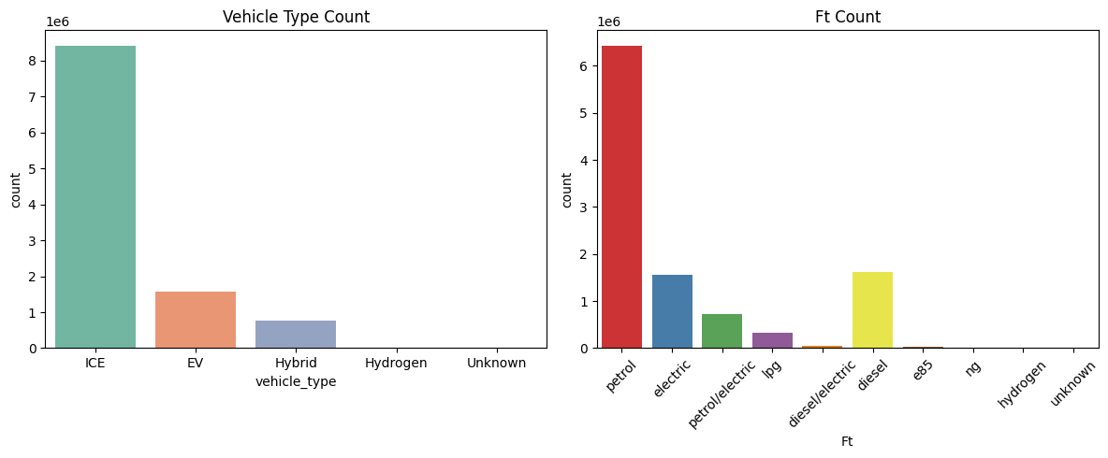
Figure 3: Count plot of Categorical features

Boxplots of Target Vs Categorical variables :

Boxtplots in the Fig 4 below ,clearly shows ICE with high emissions & EV with 0 emissions.

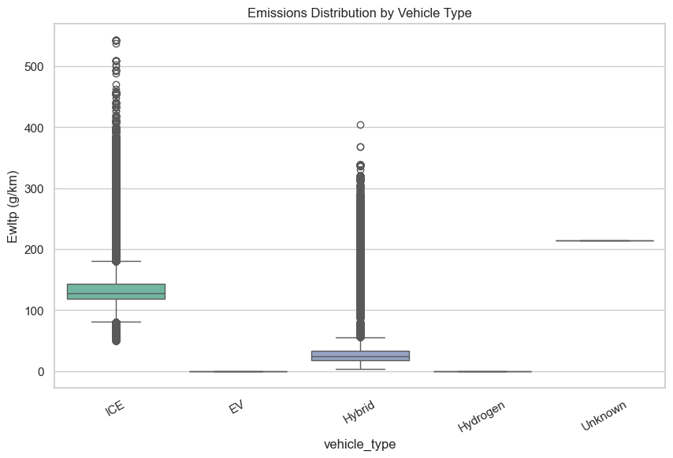
Figure 4: Boxplot of Vehicle_type Vs Target

Scatterplots for Key Categorical variables :

Scatter-plots clearly shows that more Engine Capacity(ec) more CO2 emissions as shown in the below Fig.5.

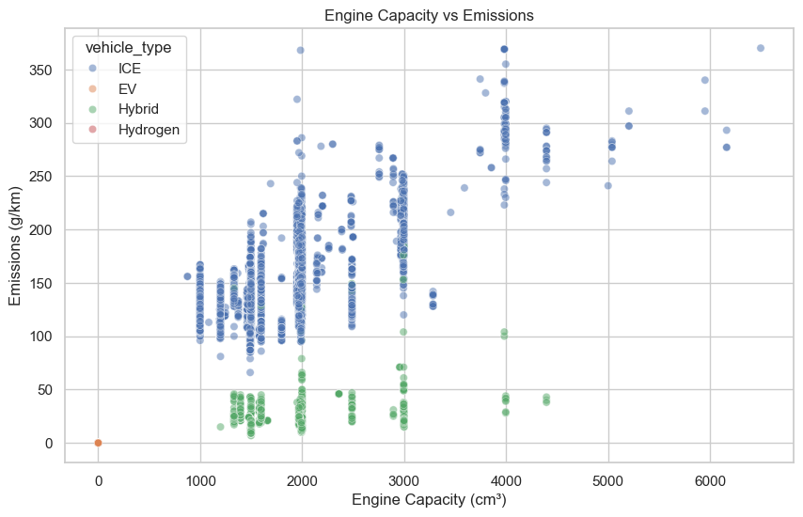
Figure 5: Scatter- plot of Categorical features

Scatter-plots also shows the EV at 0 emissions scale. Additionally , the Hybrids with varied engine capacity is also well below the emissions of an classic ICE vehicle types.

We do also see some with very large engine capacity showing very high emissions, which is also very logically true and also shown in the research papers as well.

Pair-plots

Pair plots in the below Fig.6 clearly shows the linear and nonlinear relationship of the key numerical features Vs the Target.

The ICE frequency again shows the clear domination in terms of highest count and high emissions in the dataset. Additionally , the very high correlation( highly linear ) of the Fuel consumptions Vs target again predicts that it behaves like a proxy target.( data leakage).More the power(ep-KW) more the pollution in case of ICE. Also, more the engine capacity , we can clearly see requirement of more power as well.

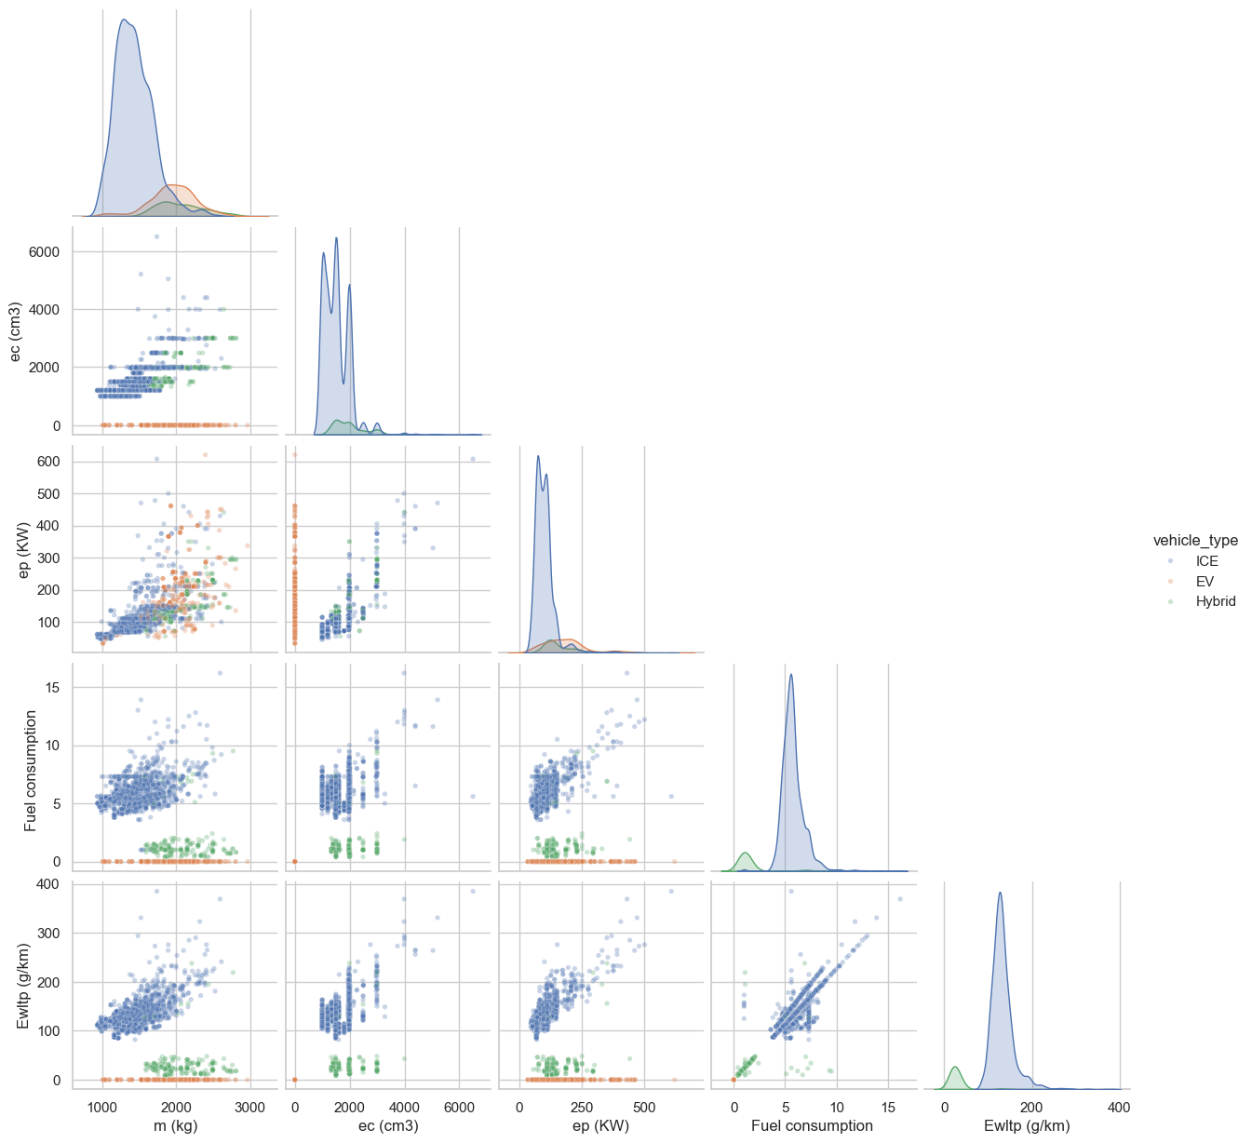

Figure 6: Pair- plot ( ICE [blue], EV(orange],Hybrid[green] )

Overall Count plot

Overall Count plots in the below Fig.7 clearly shows an overview of the feature spread Vs the corresponding total count. the linear and nonlinear relationship of the key numerical features Vs the Target.

The DE ( German ) car dominance can be clearly seen , followed with the French. Aslo, the mid economy segment of VW tops the count by manufacturer. Petrol tops the counts by fuel type. ICE frequency again shows.

Going by the count for the Innovative tech , the EV tops the count ( 0 emission logic ).

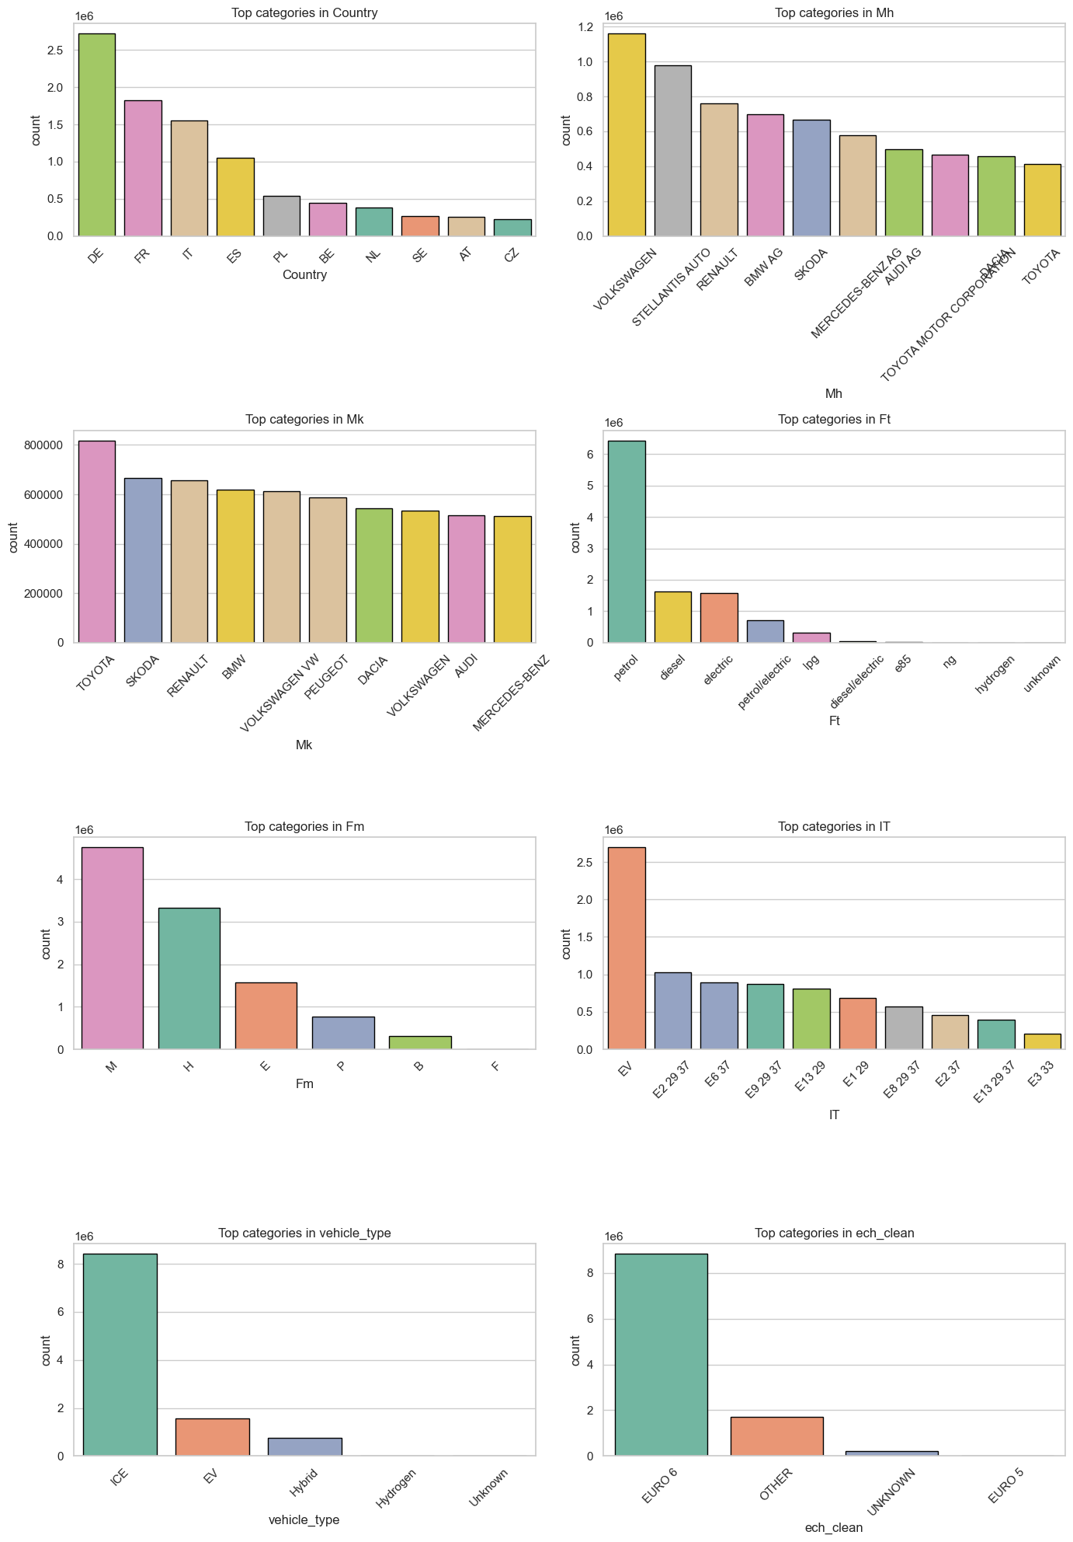

Figure 7: Overall Count plot

Final feature selection strategy and dataset construction
Based on correlation analysis and exploratory findings, a structured feature selection strategy was adopted and some of the next steps for the Report 2 is as below :

Next steps for Report 2 :

- Copy of the dataset : To keep the original an cleaned dataset.
- Train -Test split (80 /20 split)
- Encoding
- Scaling
- 2 Datasets ( to check the effect of proxy variable ) : With & Without Fuel consumption.
- Usage of Pipeline & Colum transformers
- Models that shall be checked : DummyRegressor, LinearRegression, Ridge,Lasso,ElasticNet,RandomForestRegressor,LGBMR etc
- Feature Importance
- GridsearchCV to select the right optimal parameters for the model.
- Parameter tuning

